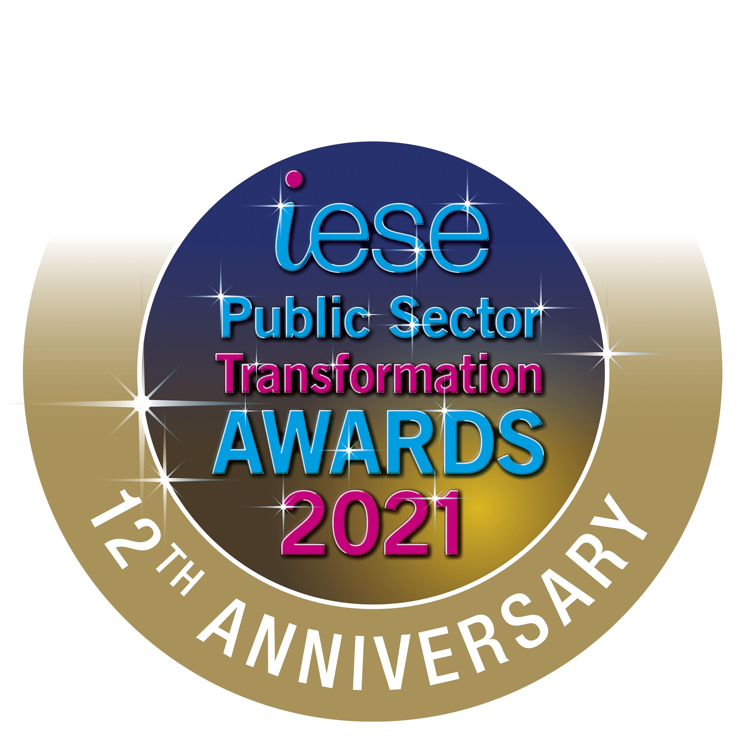

iESE is celebrating 12 years of the Public Sector Transformation Awards in March 2021, and the event shall be as glamorous as ever. Every year we receive hundreds of nominations from local authorities across the UK to achieve Gold, Silver or Bronze in each category of these Awards, which will be held in March 2020.

The awards ceremony is sponsored so that no public money is spent on the event and each winner is provided with free places in recognition of their efforts in improving their local areas.

In 2021 we are expanding the field to include entries from our public sector colleagues across the globe. We will have new categories to encompass the work being done internationally in communities overseas, embracing the spirit of celebrating good practice from a broad spectrum of experience and opportunity.

To have a look at last year’s winners, please go to the Public Sector Transformation 2020 page, and you can find the photographs of the 2020 Awards on our Facebook page.
In 2020 our awards ceremony was live streamed on our Facebook page and you can still view this now.

iESE Awards – Application Categories

1. Asset Management and Regeneration
This category is for innovative local authority-led projects that use assets to deliver proven benefits to communities.

2. Best Transformation Team
This category recognises a team who has made an exceptional contribution and long-term positive impact in their organisation through a series of transformation and continuous improvement. They continuously look for new ways to innovate and push the boundaries of local public service deployment.

3. Communications
No matter the budget, topic or channel, we are looking for excellence in public service communications campaigns; in particular the campaigns that made a real impact.

4. Community Focus
This category is for the initiative that does most to reinvigorate the local community. This might be for a major programme of regeneration that creates economic opportunity for the local area or initiatives that engage the local community, creating greater resilience, better life chances and less dependency on public services.

5. Customer Focus
Celebrating organisations that deliver outstanding service to their customers, this category recognises those that, firstly, demonstrate the link between excellent customer service and improved value to the bottom line.
6. Digital and Technology Award
This category is for the innovative use of digital tools and technology, from remodelling existing services, to creating totally new services that lead to an improved outcome and build dynamic local public services.
7. Efficiency and Effectiveness
This organisation has harnessed the real potential in their organisation, delivering elevated performance and creating efficiencies.

8. Green Council
This category recognises, rewards and promotes environmental best practice across the public sector in the UK. This organisation has shown how they have helped the environment and improved sustainability not only in their organisation, but their surrounding community.

9. Innovation
This category is not only open to the public sector but also private or third sector organisations. This category is for developing and/or bringing to market new innovative technologies or facilities that can transform the delivery of a local public service.

10. Intelligent Council
This category is for the better use of data in better decision making, transparency and understanding community need, as exemplified in the Local Government Association’s Intelligent Council Initiative.

11. Transformation in Heath & Social Care
Submissions can be based upon transforming access to services, remodelling the service, working in partnership or a combination of all three. The winning applications will have demonstrated the greatest impact for customers of health and social care.

12. Working Together
This category is for simplifying the way that residents and local businesses deal with public services, bringing together multiple contact points, removing the barriers between organisations and moving resources closer to the customer.

12th Public Sector Transformation Awards 2020
Celebrating public sector innovation and transformation
Thursday 4th March at Church House, Westminster, London

The deadline for submission is: 5pm FRIDAY, 22nd January 2021
Please send your completed application to enquiries@iese.org.uk

For help completing this nomination form, please read the notes section at the end of this document

Award  (See Note 1) |  | Asset Management and Regeneration
 |  | Best Transformation Team
 |  | Communications
 |  | Community Focus
 |  | Customer Focus
 |  | Digital and Technology
 |  | Efficiency and Effectiveness
 |  | Green Public Service
 |  | Innovation
 |  | Intelligent Council
 |  | Transformation in Health and Social Care
 |  | Working Together
 |  | Council, Fire, Ambulance and Police Service of The Year (highlight appropriate)
Organisation
(See Note 2)
Nominee
(See Note 3)
Contact | Name
 | Email address
 | Contact number
One paragraph overview of your nomination (no more than 100 words). This text will be used in the Awards Nominations Shortlist document, should you be shortlisted for an award by the judges.

Full description of your nomination (no more than 5000 words)
In your description please address the following points:
- An overview description including the purpose of the initiative, its start date and the current status (See Note 4)
- What was the problem you were trying to solve, the solution that you chose and why you chose that solution?
- Was the initiative innovative and breaking ground for the sector and if so how? (See Note 5)
- Has the initiative already demonstrated impact if so how and how much? (See Note 6)
- Has the initiative built the skills and capabilities of your staff during and post implementation, if so how? (See Note 7)

An overview description including the purpose of the initiative, its start date and the current status (See Note 4)

What was the problem you were trying to solve, the solution that you chose and why you chose that solution?

Was the initiative innovative and breaking ground for the sector and if so how? (See Note 5)

Has the initiative already demonstrated impact if so how and how much? (See Note 6)

Has the initiative built the skills and capabilities of your staff during and post implementation, if so how? (See Note 7)

Nomination Submission

Please check this box if you do not wish your information to be used as case study material for future iESE knowledge share events/publications. If used, all information will be attributed to the author organisation.

Please send your awards nomination form to enquiries@iese.org.uk with the subject line “Awards 2020 Application”. You will receive a confirmation email on receipt of your nomination form.

When submitting your nomination form, please provide a copy of your organisation’s logo and at least 2 images that can be used on the evening.

Supporting video and images: we welcome pictures and video that illustrate your initiative well. Please make it clear in your submission form or email that you have these, and provide the necessary links. If you have large file sizes, please use a file transfer tool (such as WeTransfer).

If you have any queries regarding the iESE 2021 Awards or the nomination process, please do not hesitate to contact Annabelle Spencer at annabelle.spencer@iese.org.uk

Notes

- Award Category

Your submission may be nominated for more than one award category. The judges reserve the right to move the submission to a category they deem more appropriate. The judges reserve the right to nominate the submission for additional award categories that they deem appropriate.

- Organisation

The organisation / department or individual that is the subject of the submission. This will be used on the presenation material and trophy, so please make sure the organisation name is accurate.

- Nominee

If different to the Organisation in note 2, the organisation that is making the nomination.

- Overview of the nomination

A description including the purpose of the initiative, its start date and the current status.

- Innovation

A description of why the initiative should be considered innovative. Has the approach taken to delivering the project been original? Will the initiative be deemed to have set new standards for local public service delivery and if so why? Are their best practice lessons from this initiative, if so what and how are they planned to be shared?

- Impact

Has the initiative in question proven results? Are those results outstanding and do they exceed targets; for example in comparison to other similar initiatives by individuals, departments or organisations?

- People

Has the organisation shown its commitment to its staff, the customer and its community? Has the initiative developed skills and created a platform for further transformation?

- Quality of delivery

Was the project well-conceived and planned as well as executed well and professionally? Have any big changes in working culture or customer service been implemented smoothly and without disruption?

- Contribution to the Sector

How has the authority’s work positively contributed to local government as a whole? Have they made significant progress in overcoming the issues facing local public services whether financial constraints, regeneration or in helping local businesses? Have they raised the bar in their service area? Will local government now be viewed more positively as a result of this initiative?

Scoring key as follows:

0 No reference to the criteria at all
1 – 3 Mention of criteria somewhere in the nomination
4 – 6 Described at some length, with the relevant information
7 – 10 Evidence has been given that it has been done

