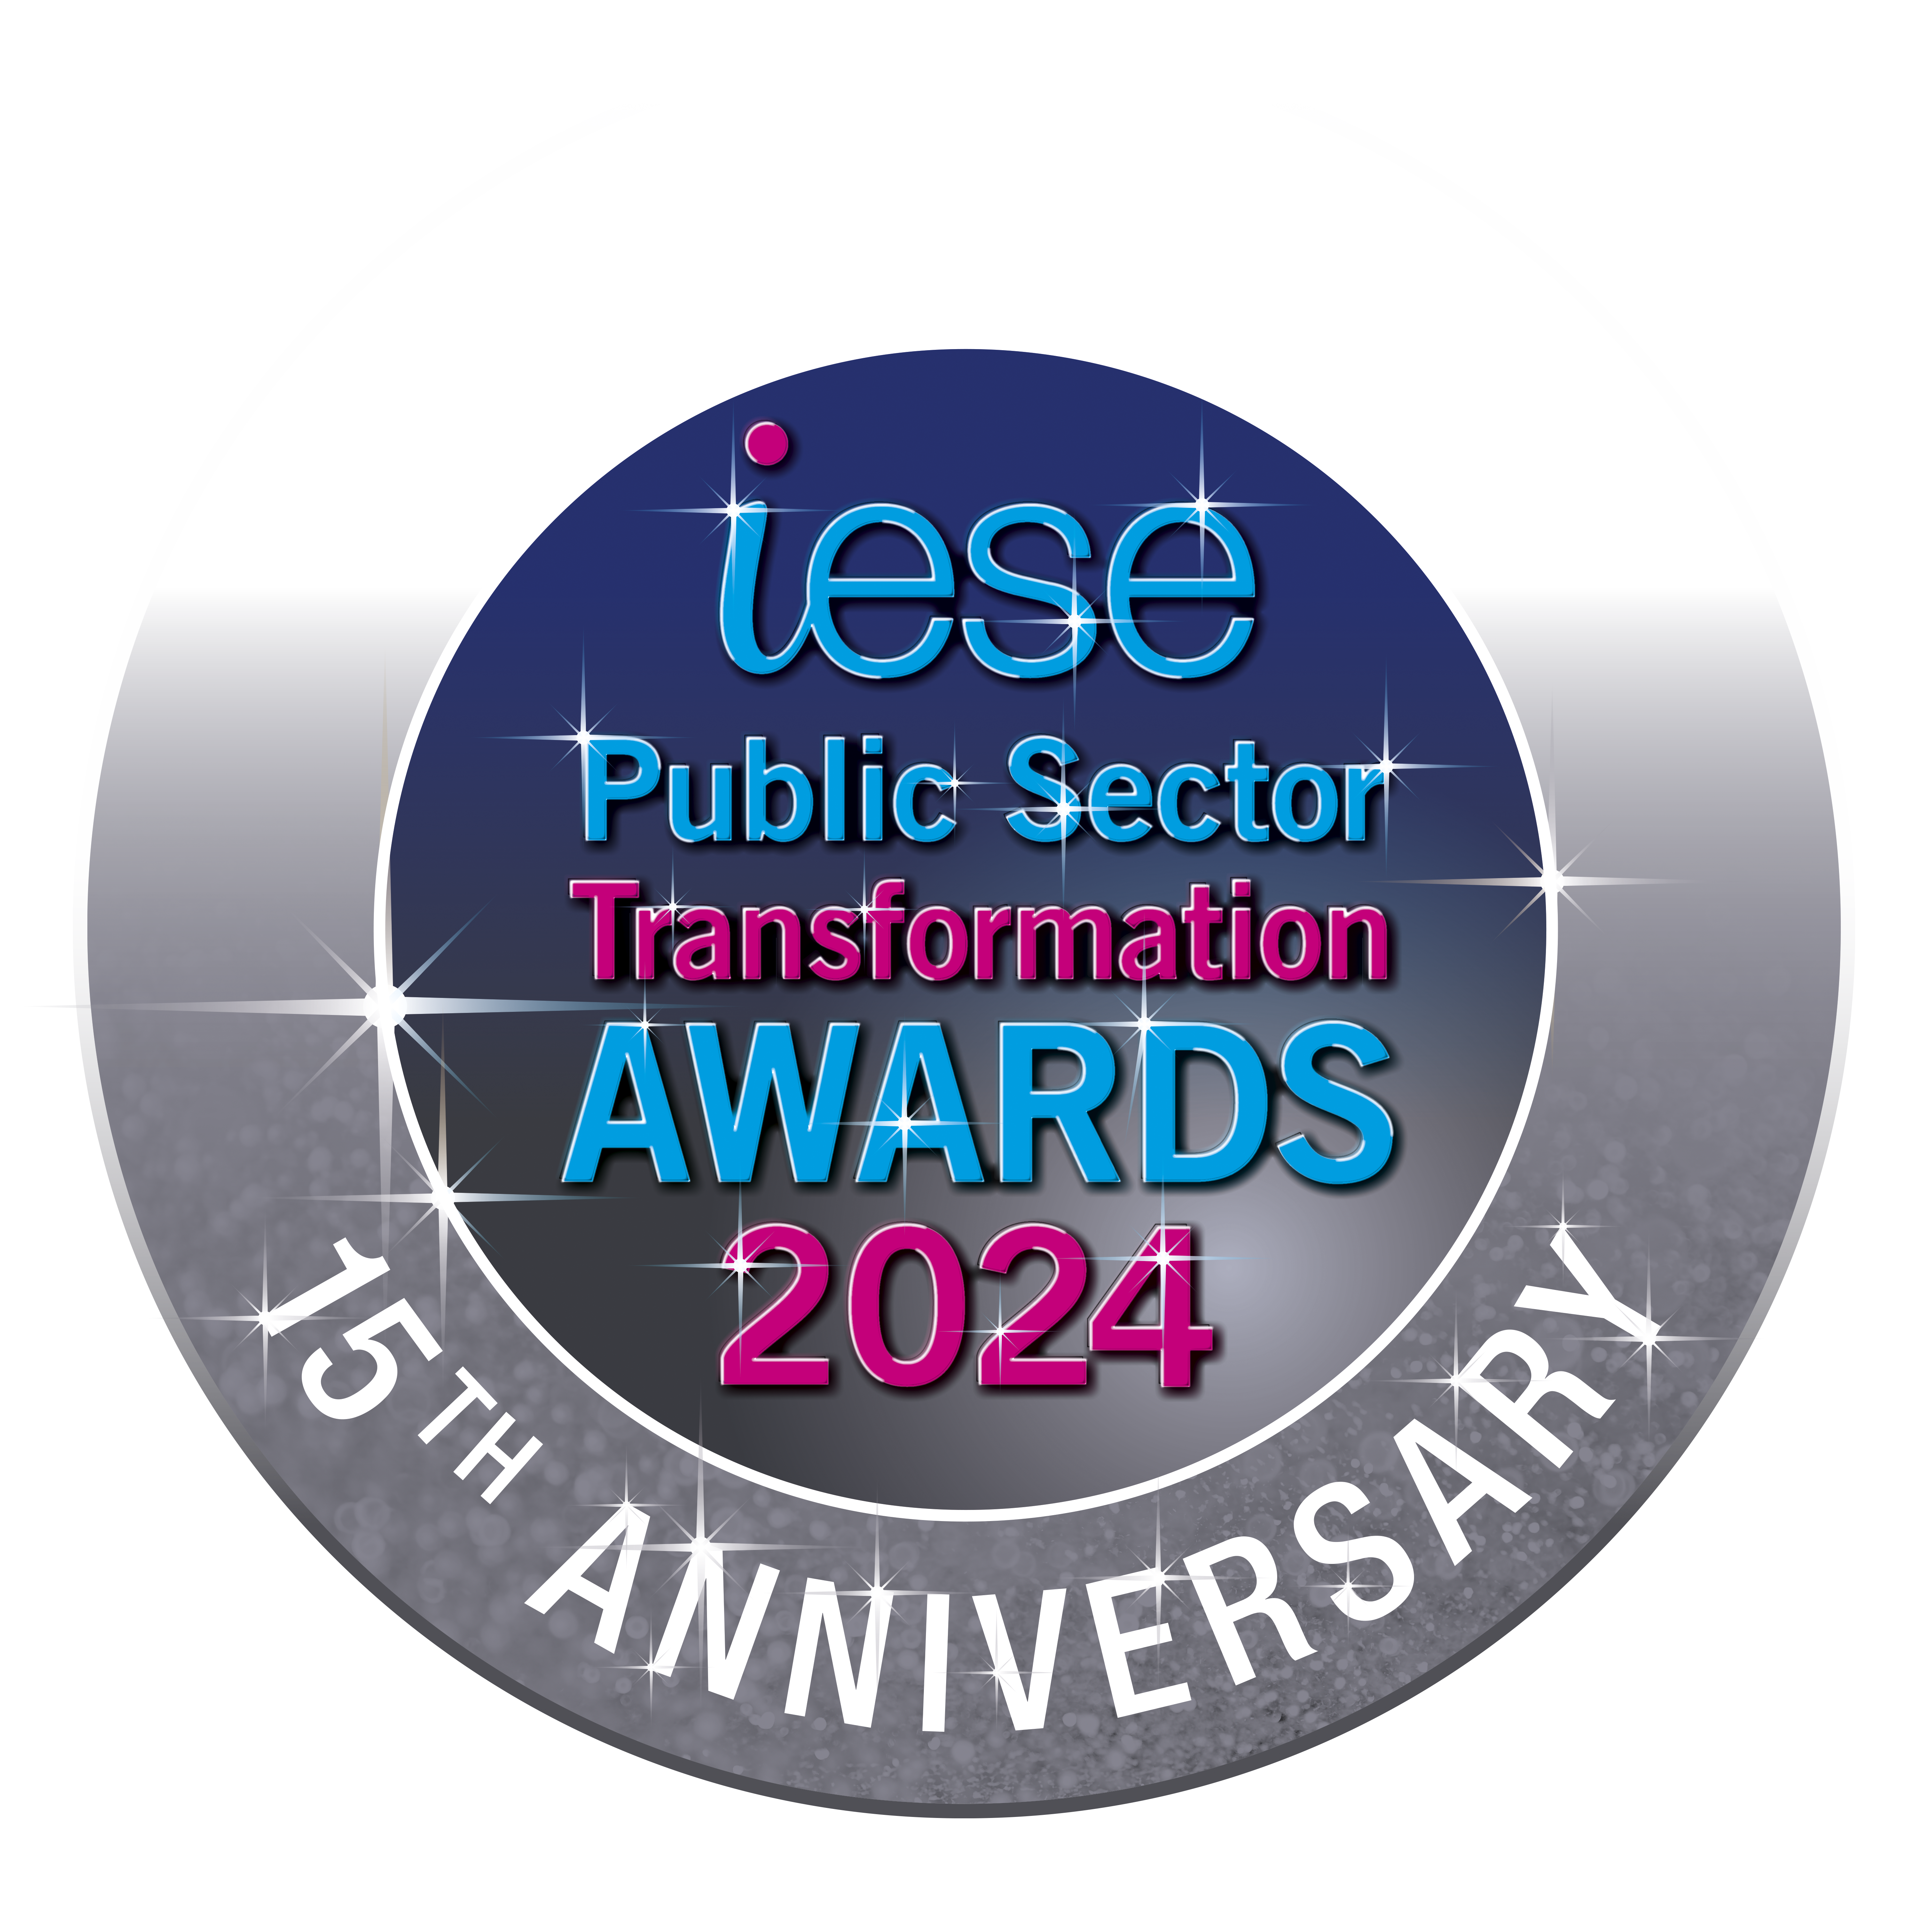

iESE is celebrating our 15th Anniversary of the Public Sector Transformation Awards in March 2024, and the event shall be our most exceptional ever, including the launch of the iESE Hall of Fame!

Every year we receive hundreds of nominations from public sector organisations across the UK and overseas to achieve Gold, Silver or Bronze in each award category. This year the awards ceremony will be held on Wednesday 6th March 2024 at Church House in London.

The awards ceremony is sponsored so that no public money is spent on the event. We invite two representatives free of charge from each finalist organisation to attend the awards ceremony in recognition of their efforts in improving their local areas.

Following the recent year’s success of our presentation of International Public Body of the Year, in 2024 we will continue our endeavours to include entries from our public sector colleagues across the globe. We have also adapted our categories to encompass the work being done internationally in communities overseas, embracing the spirit of celebrating good practice from a broad spectrum of experience and opportunity.

To have a look at last year's winners, please go to the Public Sector Transformation 2023 page you can find the photographs of the 2023 Awards on our Facebook page.
Each year, our awards ceremony is live streamed on YouTube and you can still view this now.
If you have any questions or queries about our awards, please contact enquiries@iese.org.uk.

iESE Awards – Application Categories

1. Best Transformation Team

This award captures the exceptional focus and effort from a team who has made a significant contribution and long-term positive impact within their organisation, on their residents and communities. They have improved outcomes for their organisation, customers, and wider community through innovative transformation and continuous improvement. This team has delivered the best possible services to their residents and service users by embedding strong values, culture and behaviours.

2. Community and Customer Focus Award
This award is for the initiative that does most to reinvigorate the local community and deliver outstanding service to their customers. Through the use of asset management and regeneration, they have created opportunities for their local area by delivering proven benefits, greater resilience and less dependency on local public services. And they can clearly demonstrate the link between excellent customer service and improved service performance.

3. Best Use of Digital, Technology and Data Insight

This category is for the innovative use of digital tools, technology, and data that have led to improved outcomes for their organisation, customers, and wider community. This could be from remodelling existing services, to creating totally new and dynamic services that have transformed the roll of the local public services and the way it supports its residents and communities. Within their submission, they have evidenced and highlighted their creative approach of managing and manipulating data to deliver outstanding results.

4. Award for Efficiency and Effectiveness
This body has harnessed the real potential in their organisation, delivering elevated performance, creating efficiencies, and delivering outstanding customer service with improved value to their residents. Above all, this organisation has shown its ability to adapt to a fast-paced and ever-changing environment, while achieving fantastic results in doing so.

5. Green Public Service Award

This category recognises, rewards and promotes environmental best practice across the public sector in the UK. This organisation has shown how they have helped the environment by driving sustainability not only in their organisation, but in their surrounding local area, and have improved the quality of life and well-being of their local residents.

6. Award for Innovation

This category is for developing and bringing to market new innovative technologies, facilities or services that can transform the delivery of a local public service. They are able to show the success of innovative ways of working, and the improvement it’s made to their customers and community. This category is not only open to the public sector but also to private or third sector organisations.

7. Transformation in Health & Social Care Award
This organisation has highlighted the greatest impact for customers of health and social care, through the successful launch of creative and forward-thinking services for children, young people or adults. Submissions can be based upon transforming access to services, remodelling the service itself, or integrating different services and partners.

8. Working Together Award
This category is for simplifying the way that residents and local businesses deal with public services, bringing together multiple contact points, removing the barriers between organisations and moving resources closer to the customer.

International Public Body of the Year 2024

This award is presented to an International Public Body deemed outstanding in transforming the delivery of its services.

UK Police Service of the Year 2024

This award is presented to a Police Service deemed outstanding in transforming the delivery of its services.

UK Fire & Rescue Service of the Year 2024

This award is presented to the Fire & Rescue Service deemed outstanding in transforming the delivery of its services.

UK Council of the Year 2024

This award is presented to a Council deemed outstanding in transforming its services and creating and supporting vibrant communities.

15th Public Sector Transformation Awards 2024
Celebrating public sector innovation and transformation
Wednesday 6th March at Church House, Westminster, London

The deadline for submission is: 5pm FRIDAY 12th January 2024
Please send your completed application to enquiries@iese.org.uk

For help completing this nomination form, please read the notes section at the end of this document

Award  (See Note 1) |  | Best Transformation Team
Award  (See Note 1) |  | Community and Customer Focus Award
Award  (See Note 1) |  | Best Use of Digital, Technology and Data Insight
Award  (See Note 1) |  | Efficiency and Effectiveness
Award  (See Note 1) |  | Green Public Service Award
Award  (See Note 1) |  | Innovation
Award  (See Note 1) |  | Transformation in Health and Social Care
Award  (See Note 1) |  | Working Together
Award  (See Note 1) |  | Council of the Year
Award  (See Note 1) |  | UK Police Service of the Year
Award  (See Note 1) |  | UK Fire & Rescue Service of the Year
Award  (See Note 1) |  | International Public Body of the Year
Organisation Name
(See Note 2)
Nomination Title
(See Note 3)
Nomination Contact | Name
Nomination Contact | Email address
Nomination Contact | Contact number
One paragraph overview of your nomination (no more than 100 words). This text will be used in the Awards Nominations Shortlist document, should you be shortlisted for an award by the judges.

Full description of your nomination (no more than 5000 words)
In your description, please address the following points:
- An overview description including the purpose of the initiative, its start date and the current status (See Note 4)
- What was the problem you were trying to solve, the solution that you chose and why you chose that solution?
- Was the initiative innovative and breaking ground for the sector and if so, how? (See Note 5)
- Has the initiative already demonstrated impact if so how and how much? (See Note 6)
- Has the initiative built the skills and capabilities of your staff during and post implementation, if so, how? (See Note 7)

Nomination Submission

Please check this box if you do not wish your information to be used as case study material for future iESE knowledge share events/publications. If used, all information will be attributed to the author organisation.

Please send your awards nomination form to enquiries@iese.org.uk with the subject line “Awards 2024 Application”. You will receive a confirmation email on receipt of your nomination form.

When submitting your nomination form, please provide a copy of your organisation’s logo and at least 2 images that can be used on the evening.

Supporting video and images: we welcome pictures and video that illustrate your initiative well. Please make it clear in your submission form or email that you have these, and provide the necessary links. If you have large file sizes, please use a file transfer tool (such as WeTransfer).

If you have any queries regarding the iESE 2024 Awards or the nomination process, please do not hesitate to contact Annabelle Atkin at annabelle.atkin@iese.org.uk.

Notes

- Award Category

Your submission may be nominated for more than one award category. The judges reserve the right to move the submission to a category they deem more appropriate. The judges reserve the right to nominate the submission for additional award categories that they deem appropriate.

- Organisation

The name of the organisation that is the subject of the submission. This will be used on the presentation material and trophy, so please make sure the organisation name is accurate.

- Nomination Title

This is the title of your nominated project, programme, team/department or piece of work that you are submitting to the iESE Awards. This will be used on the presentation material and trophy, so please make sure the organisation name is accurate.

- Overview of the nomination

A description including the purpose of the initiative, its start date and the current status.

- Innovation

A description of why the initiative should be considered innovative. Has the approach taken to delivering the project been original? Will the initiative be deemed to have set new standards for local public service delivery and if so why? Are their best practice lessons from this initiative, if so what and how are they planned to be shared?

- Impact

Has the initiative in question proven results? Are those results outstanding and do they exceed targets; for example, in comparison to other similar initiatives by individuals, departments or organisations?

- People

Has the organisation shown its commitment to its staff, the customer and its community? Has the initiative developed skills and created a platform for further transformation?

- Quality of delivery

Was the project well-conceived and planned as well as executed well and professionally? Have any big changes in working culture or customer service been implemented smoothly and without disruption?

- Contribution to the Sector

How has the authority’s work positively contributed to local government as a whole? Have they made significant progress in overcoming the issues facing local public services whether financial constraints, regeneration or in helping local businesses? Have they raised the bar in their service area? Will local government now be viewed more positively as a result of this initiative?

Scoring key as follows:

0 No reference to the criteria at all
1 – 3 Mention of criteria somewhere in the nomination
4 – 6 Described at some length, with the relevant information
7 – 10 Evidence has been given that it has been done

