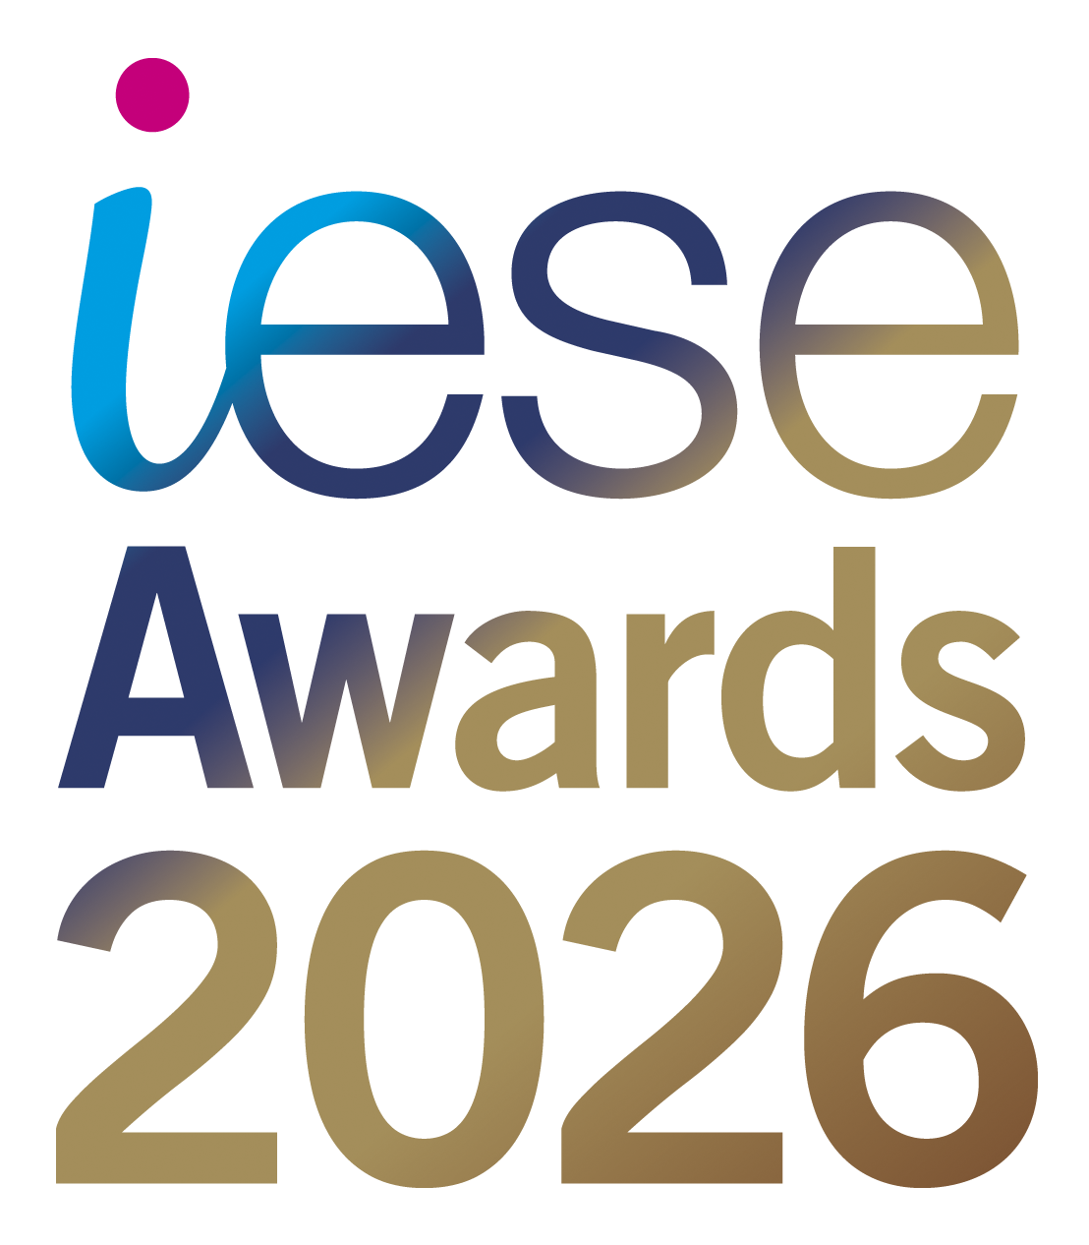
The iESE Public Sector Transformation Awards recognise and celebrate the outstanding work of councils, public bodies, and their partners in improving services and delivering better outcomes for communities. From innovative digital solutions to groundbreaking community initiatives, the Awards shine a spotlight on the people and projects driving positive change. Whether large-scale transformation or local grassroots impact, every nomination helps showcase the dedication, creativity, and commitment of those working to make public services the best they can be.

iESE is proud to bring you its 17th Public Sector Transformation Awards, and this year promises to be more spectacular than ever. Every year, we receive hundreds of nominations from public sector organisations across the UK and overseas, competing for Gold, Silver, or Bronze in each award category. The 2026 Awards Ceremony will take place on Wednesday 4th March 2026 at Church House, London.

Thanks to the generosity of our sponsors, no public money is spent on the event. We are delighted to invite two representatives from each finalist organisation to attend the ceremony free of charge, in recognition of their hard work and commitment to improving their communities.

Following the success of 2024’s launch of the iESE Hall of Fame, our top-achieving organisations will once again be recognised at the Awards ceremony. Through our Hall of Fame, we continue to showcase and share learning, best practice, and inspiring stories from across the sector, and by submitting a nomination, your organisation could join them.

The iESE Awards continue to grow internationally, building on the success of recent years with our International Public Body of the Year category. For 2026, we are further embracing entries from public sector colleagues across the globe, with award categories designed to celebrate the outstanding work taking place in communities worldwide.

To see last year’s winners, visit the Public Sector Transformation Awards 2025 page, and take a look at the photographs from the evening on our Facebook page. The ceremony is also live-streamed each year on YouTube, and you can still watch the 2025 event online.

If you have any questions about the iESE Awards, please contact michelle.pearson@iese.org.uk.

iESE Awards – Application Categories

1. AI in Public Services Award
This award recognises the most impactful and ethical use of Artificial Intelligence in transforming local public services. Entrants will demonstrate how AI has been applied to improve decision-making, enhance service delivery, reduce costs, or predict and meet community needs — all while ensuring transparency, accountability, and public trust. Submissions can include automation, predictive analytics, natural language processing, or other AI-driven innovations that deliver measurable benefits to residents and communities.

2. Best Transformation Team
This award captures the exceptional focus and effort from a team who has made a significant contribution and long-term positive impact within their organisation, on their residents and communities. They have improved outcomes for their organisation, customers, and wider community through innovative transformation and continuous improvement. This team has delivered the best possible services to their residents and service users by embedding strong values, culture, and behaviours. Nominations are welcome from both single organisations and cross-agency teams.

3. Best Use of Digital, Technology and Data Insight
This category is for the innovative use of digital tools, technology, and data that have led to improved outcomes for the organisation, customers, and wider community. This could range from remodelling existing services to creating new, dynamic services that have transformed the role of local public services and the way they support residents and communities. Entries must evidence a creative approach to managing and analysing data to deliver outstanding results.

4. CareCubed Award
This award recognises organisations that have used CareCubed, the National Care Costing Tool, to enhance transparency, efficiency, and collaboration in care commissioning and delivery. Entries should demonstrate measurable outcomes such as improved cost accuracy, stronger provider relationships, or more sustainable care models. Projects should show how CareCubed has been embedded in teams, driven cost savings, and supported data-driven decision-making.

5. Collaboration & Partnership Award
This category recognises the simplification of how residents and local businesses interact with public services by bringing together multiple contact points, removing barriers between organisations, and moving resources closer to the customer. It also celebrates strategic alliances, co-production with communities, and joint working between different sectors to achieve shared goals.

6. Community and Customer Focus Award
This award is for the initiative that does most to reinvigorate the local community and deliver outstanding service to customers. Through the use of asset management, regeneration, or community development, they have created opportunities for their local area by delivering proven benefits, greater resilience, and less dependency on local public services. Entrants must clearly demonstrate the link between excellent customer service and improved service performance.

7. Cyber Resilience Award
This category rewards successful initiatives that improve the overall security of their organisation.They have demonstrated exceptional commitment to strengthening their cyber resilience by embedding a culture of cyber security throughout their operations. The award recognises those who have proactively invested in robust security measures, delivered effective staff training, and promoted cyber knowledge at every level of the organisation.

8. Efficiency and Effectiveness Award
This category recognises organisations that have unlocked the full potential of their resources to deliver elevated performance, create efficiencies, and deliver outstanding customer service with improved value to residents. Above all, this organisation has shown its ability to adapt to a fast-paced and ever-changing environment while achieving excellent results.

9. Green Public Service Award
This category recognises, rewards, and promotes environmental best practice across the public sector in the UK. The winning organisation will demonstrate how they have driven sustainability within their operations and local area, addressed climate adaptation and biodiversity, and improved the quality of life and well-being of their residents.

10. Innovation Award
This category is for developing and bringing to market new innovative technologies, facilities, or services that can transform the delivery of a local public service. Entrants will be able to show the success of innovative ways of working and the improvement made to their customers and community. This category is open to public, private, and third sector organisations.

11. Transformation in Health & Social Care Award
This organisation has highlighted the greatest impact for customers of health and social care through the successful launch of creative and forward-thinking services for children, young people, or adults. Submissions can be based upon transforming access to services, remodelling the service itself, or integrating different services and partners.

12. International Public Body of the Year 2026

The International Public Body of the Year is the ultimate award recognising outstanding public sector transformation on a global scale. It celebrates an organisation that has delivered exceptional services, innovation, and measurable impact for communities around the world.

13. UK Police Service of the Year 2025

The UK Police Service of the Year is the highest accolade for policing excellence. It celebrates a service that has transformed operations, enhanced public safety, and delivered measurable benefits for the communities it protects.

14. UK Fire & Rescue Service of the Year 2025

The UK Fire & Rescue Service of the Year is the pinnacle award for excellence in fire and rescue. It recognises a service that has transformed operations, improved safety, and delivered outstanding impact for the communities it serves.

15. UK Council of the Year 2025

This is the most prestigious award of the iESE Awards, presented to a Council that has demonstrated exceptional leadership, innovation, and impact. The winner will have transformed services, strengthened communities, and delivered measurable improvements for residents, setting the benchmark for excellence in local government.

17th Public Sector Transformation Awards 2026
Celebrating public sector innovation and transformation
Wednesday 4th March 2026 at Church House, Westminster, London

The deadline for submission is: 5pm FRIDAY 9th January 2026
Please send your completed application to enquiries@iese.org.uk

For help completing this nomination form, please read the notes section at the end of this document

Award  (See Note 1) |  | AI in Public Services Award
Award  (See Note 1) |  | Best Transformation Team
Award  (See Note 1) |  | Best Use of Digital, Technology and Data Insight
Award  (See Note 1) |  | CareCubed Award
Award  (See Note 1) |  | Collaboration and Partnership Award
Award  (See Note 1) |  | Community and Customer Focus Award
Award  (See Note 1) |  | Cyber Resilience Award
Award  (See Note 1) |  | Efficiency and Effectiveness Award
Award  (See Note 1) |  | Green Public Service Award
Award  (See Note 1) |  | Innovation
Award  (See Note 1) |  | Transformation in Health and Social Care
Award  (See Note 1) |  | Council of the Year
Award  (See Note 1) |  | UK Police Service of the Year
Award  (See Note 1) |  | UK Fire & Rescue Service of the Year
Award  (See Note 1) |  | International Public Body of the Year
Organisation Name
(See Note 2)
Nomination Title
(See Note 3)
Nomination Contact | Name
Nomination Contact | Email address
Nomination Contact | Contact number
One paragraph overview of your nomination (no more than 100 words). This text will be used in the Awards Nominations Shortlist document, should you be shortlisted for an award by the judges.

Full description of your nomination (no more than 5000 words)
In your description, please address the following points:
- An overview description including the purpose of the initiative, its start date and the status (See Note 4)
- What was the problem you were trying to solve, the solution that you chose and why you chose that solution?
- Was the initiative innovative and breaking ground for the sector and if so, how? (See Note 5)
- Has the initiative already demonstrated impact if so how and how much? (See Note 6)
- Has the initiative built the skills and capabilities of your staff during and post implementation, if so, how? (See Note 7)

Nomination Submission

Please check this box if you do not wish your information to be used as case study material for future iESE knowledge share events/publications. If used, all information will be attributed to the author organisation.

Please send your awards nomination form to enquiries@iese.org.uk with the subject line “Awards 2026 Application”. You will receive a confirmation email on receipt of your nomination form.

When submitting your nomination form, please provide a copy of your organisation’s logo and at least 2 images that can be used in our special award winners edition of Transform Magazine.

Supporting video and images: we welcome pictures and video that illustrate your initiative well. Please make it clear in your submission form or email that you have these and provide the necessary links. If you have large file sizes, please use a file transfer tool (such as WeTransfer).

If you have any queries regarding the iESE 2026 Awards or the nomination process, please do not hesitate to contact Michelle Pearson at michelle.pearson@iese.org.uk.

Notes

- Award Category

Your submission may be nominated for more than one award category. The judges reserve the right to move the submission to a category they deem more appropriate. The judges reserve the right to nominate the submission for additional award categories that they deem appropriate.

- Organisation

The name of the organisation that is the subject of the submission. This will be used on the presentation material and trophy, so please make sure the organisation name is accurate.

- Nomination Title

This is the title of your nominated project, programme, team/department or piece of work that you are submitting to the iESE Awards. This will be used on the presentation material and trophy, so please make sure the organisation name is accurate.

- Overview of the nomination

A description including the purpose of the initiative, its start date and the status.

- Innovation

A description of why the initiative should be considered innovative. Has the approach taken to delivering the project been original? Will the initiative be deemed to have set new standards for local public service delivery and if so why? Are their best practice lessons from this initiative, if so what and how are they planned to be shared?

- Impact

Has the initiative in question proven results? Are those results outstanding, and do they exceed targets; for example, in comparison to other similar initiatives by individuals, departments or organisations?

- People

Has the organisation shown its commitment to its staff, the customer and its community? Has the initiative developed skills and created a platform for further transformation?

- Quality of delivery

Was the project well-conceived and planned as well as executed well and professionally? Have any big changes in working culture or customer service been implemented smoothly and without disruption?

- Contribution to the Sector

How has the authority’s work positively contributed to local government as a whole? Have they made significant progress in overcoming the issues facing local public services whether financial constraints, regeneration or in helping local businesses? Have they raised the bar in their service area? Will local government now be viewed more positively because of this initiative?

Scoring key as follows:

0 No reference to the criteria at all
1 – 3 Mention of criteria somewhere in the nomination
4 – 6 Described at some length, with the relevant information
7 – 10 Evidence has been given that it has been done

